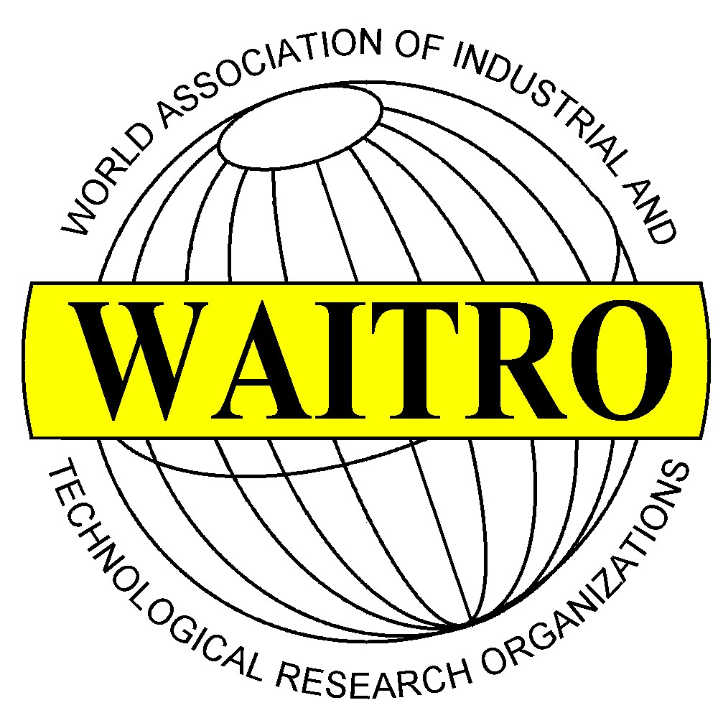

WAITRO African Regional Focal Point Members, March 2009

World Association of Industrial and Technological Research Organisations
Country | Institute
Benin | College, Polytechnique, Universitaire, CPU
Benin | International Centre for Applied Research in Food & Nutrition
Botswana | Botswana Technology Centre, BOTEC
Botswana | National Food Technology Research Centre, NFTRC
Botswana | Rural Industries Promotions Company, RIPCO
Burkina Faso | Department of Food Technology, DTA
Burkina Faso | Ougadougou Institute for Energy, IBEO
Burkina Faso | Laboratory of Applied Organic Chemistry, LCO
Cameroon | Observatoire Camerounais de Qualite, OCQ
Cameroon | Department of Organic Chemistry, UY/DOC
Cameroon | Rural Enterprise Development Centre, REDC
Congo | Centre de recherché et d’Initiation des Projects de Technologie, CRIPT
Conto, Dem. Rep | Agro – Alimentary Research Centre, CRAA
Cotes Divoire | Station de Recherches Technoligiques, SRT
Etiopia | Ethiopian Health and Nutrition Research Institute, EHNRI
Ghana | Biotechnology & Nuclear Agriculture Research Institute, BNARI
Ghana | Building and Road Research Institute, BRRI
Ghana | CSIR-Institute of Industrial Research, CSIR-IIR
Ghana | Deng Limited, DENG
Ghana | Food Research Institute, Council for Scientific and Industrial Research, FRI
Ghana | Savanna Agricultural Research Institute, SARI
Ghana | Science & Technology Policy Research Institute, STEPRI
Guinea | Guinean Association for Women in Research, AGFC
Guinea | Direction Nationale de la Recherche Scientifique et Technique, DNRST
Kenya | African Institute for Capacity Development, AICAD
Kenya | Appropriate Technology Centre, ATC
Kenya | Department of Mechanical Engineering, DME
Kenya | International Centre of Insect Physiology & Ecology, ICIPE
Kenya | Jomo Kenyatta University of Agriculture & Technology, JKUAT
Kenya | Kenya Industrial Research & Development Institute, KIRDI
Kenya | Kenya Medical Research Institute, KEMRI
Lesotho | Appropriate Technology Section, ATS
Malawi | Malawi Industrial Research & Technology Development Centre, MIRTDC
Mali | National Centre for Solar Energy & Renewable Energy, CNESOLER
Mauritius | Small & Medium Industries Development Organisation, SMIDO
Niger | Centre National d’Energie Solaire, CNES
Nigeria | Federal Institute of Industrial Research Oshodi, FIIRO
Nigeria | National Metallurgical Development Centre, NMDC
Nigeria | Projects Development Institute, PRODA
Nigeria | Raw Material Research & Development Council, RMRDC
Nigeria | Technology Planning & Development Unit, TDDU
Rwanda | Scientific & Technological Research Institute, STRI
Senegal | African Regional Centre for Technology, ARCT
Senegal | Ecole Superieure Polytechnique, ENSUT
Sierra Leone | University Research and Development Services Bureau, URDS
South Africa | Agricultural Research Council, ARC
South Africa | Council for Scientific and Industrial Research, CSIR
South Africa | South African Bureau of Standards Holdings (Pty) Ltd, SABS
Sudan | Building & Road Research Institute, BRRI
Sudan | Food Research Centre, FRC
Sudan | Industrial Research and Consultancy Centre, IRCC
Sudan | Sudan University of Science & Technology, SUST
Tanzania | Tanzania Engineering & Manufacturing & Design Organisation, TEMDO
Tanzania | Tanzania Industrial Research & Development Organisation, TIRDO
Uganda | Uganda Industrial Research Institute, UIRI
Uganda | Uganda National Bureau of Standards, UNBS
Zambia | National Institute for Scientific & Industrial Research, NISIR
Zambia | Small Enterprises Development Board, SEDB
Zimbabwe | Development Technology Centre, DTC
Zimbabwe | Scientific & Industrial Research & Development Centre, SIRDC

